Projectile Motion

Experiment

By: Jacob Richards

Lab Partner: Adam Whitten

**Abstract:** The objective of this experiment is to measure the speed at which a projectile leaves a spring gun and to predict the landing point when the projectile is fired at a nonzero angle of elevation. Also, to predict the angle that produces the greatest range in our experiment due to the inequality of heights of the launch and landing surfaces.

**Results:**

**Part 2)**

Total height: h = 1.198 meters

**Part 3)**

Time the ball stays in the air (when fired horizontally): t = 0.49 seconds

**Part 5)**

Average horizontal distance traveled: Xavg = 2.433 meters

Speed that the ball leaves the gun: Vo = 4.92 meters / second

**Part 7)**

Time that the ball stays in the air (when fired at 45o): t = 0.964 seconds

Horizontal range: x = 3.354 meters

**Part 8)**

Percentage difference between the actual distance traveled and the theoretical value:

%*difference =* 1.64%

**Part 9)**

Distance traveled at other angles:

X40o = 3.513 meters

X35o = 3.449 meters

X30o = 3.439 meters

X25o = 3.369 meters

**Sample Calculations:**

**From Part 3)**

To find the time the ball stays in the air when fired horizontally:

t = = = 0.49seconds

**From Part 5)**

To find the initial velocity of the ball when fired out of the gun:

V0 = = = 4.92 meters/second

**From Part 7)**

To find the x and y components of the velocity when fired at 45°:

V0y = 4.92sin45° = 3.48m/s

V0x = 4.92sin45° = 3.48m/s

To find the time the ball stays in the air when fired at 45°:

y = y0 + 3.48t - 4.9t2

0 = 1.198 + 3.48t – 4.9t2

t = = = 0.964 seconds

To find the horizontal distance traveled by the ball when fired at 45°:

x = x0 + V0xt

Δx = V0xt = 3.48*0.964 = 3.354 meters

**From Part 8)**

To calculate %*difference* between our actual Δx and the theoretical Δx:

= = .0164 = 1.64%

**Discussion of Results:** The objectives of this experiment, as stated above, were to measure the speed at which a projectile leaves a spring gun, to predict the landing point when the projectile is fired at a nonzero angle of elevation, and to predict the angle that produces the greatest range in our experiment due to the inequality of heights of the launch and landing surfaces. We were able to successfully measure the approximate speed at which the projectile leaves the gun. Using this measurement, we were able to successfully calculate the distance to the landing point at which the ball would land. We were within just 1.64% of our predicted landing point distance. This %*difference* can be attributed to uncertainty in our measurement instrument, being a ruler. Also, a source of uncertainty that could have potential thrown off our prediction a little bit would be inconsistent launches from the gun. When measuring the initial distances that the ball traveled (when fired horizontally) the ball traveled slightly different distances each time. Also, we discovered that the angle of elevation that provided the greatest range was actually less than 45°. This is due to the fact that our launch and landing surfaces were at different heights. In fact, the optimal angle likely lies around 40°. Of our five measurements from 45° to 25°, 40° provided the greatest range by about 0.7 meters.

**Data**

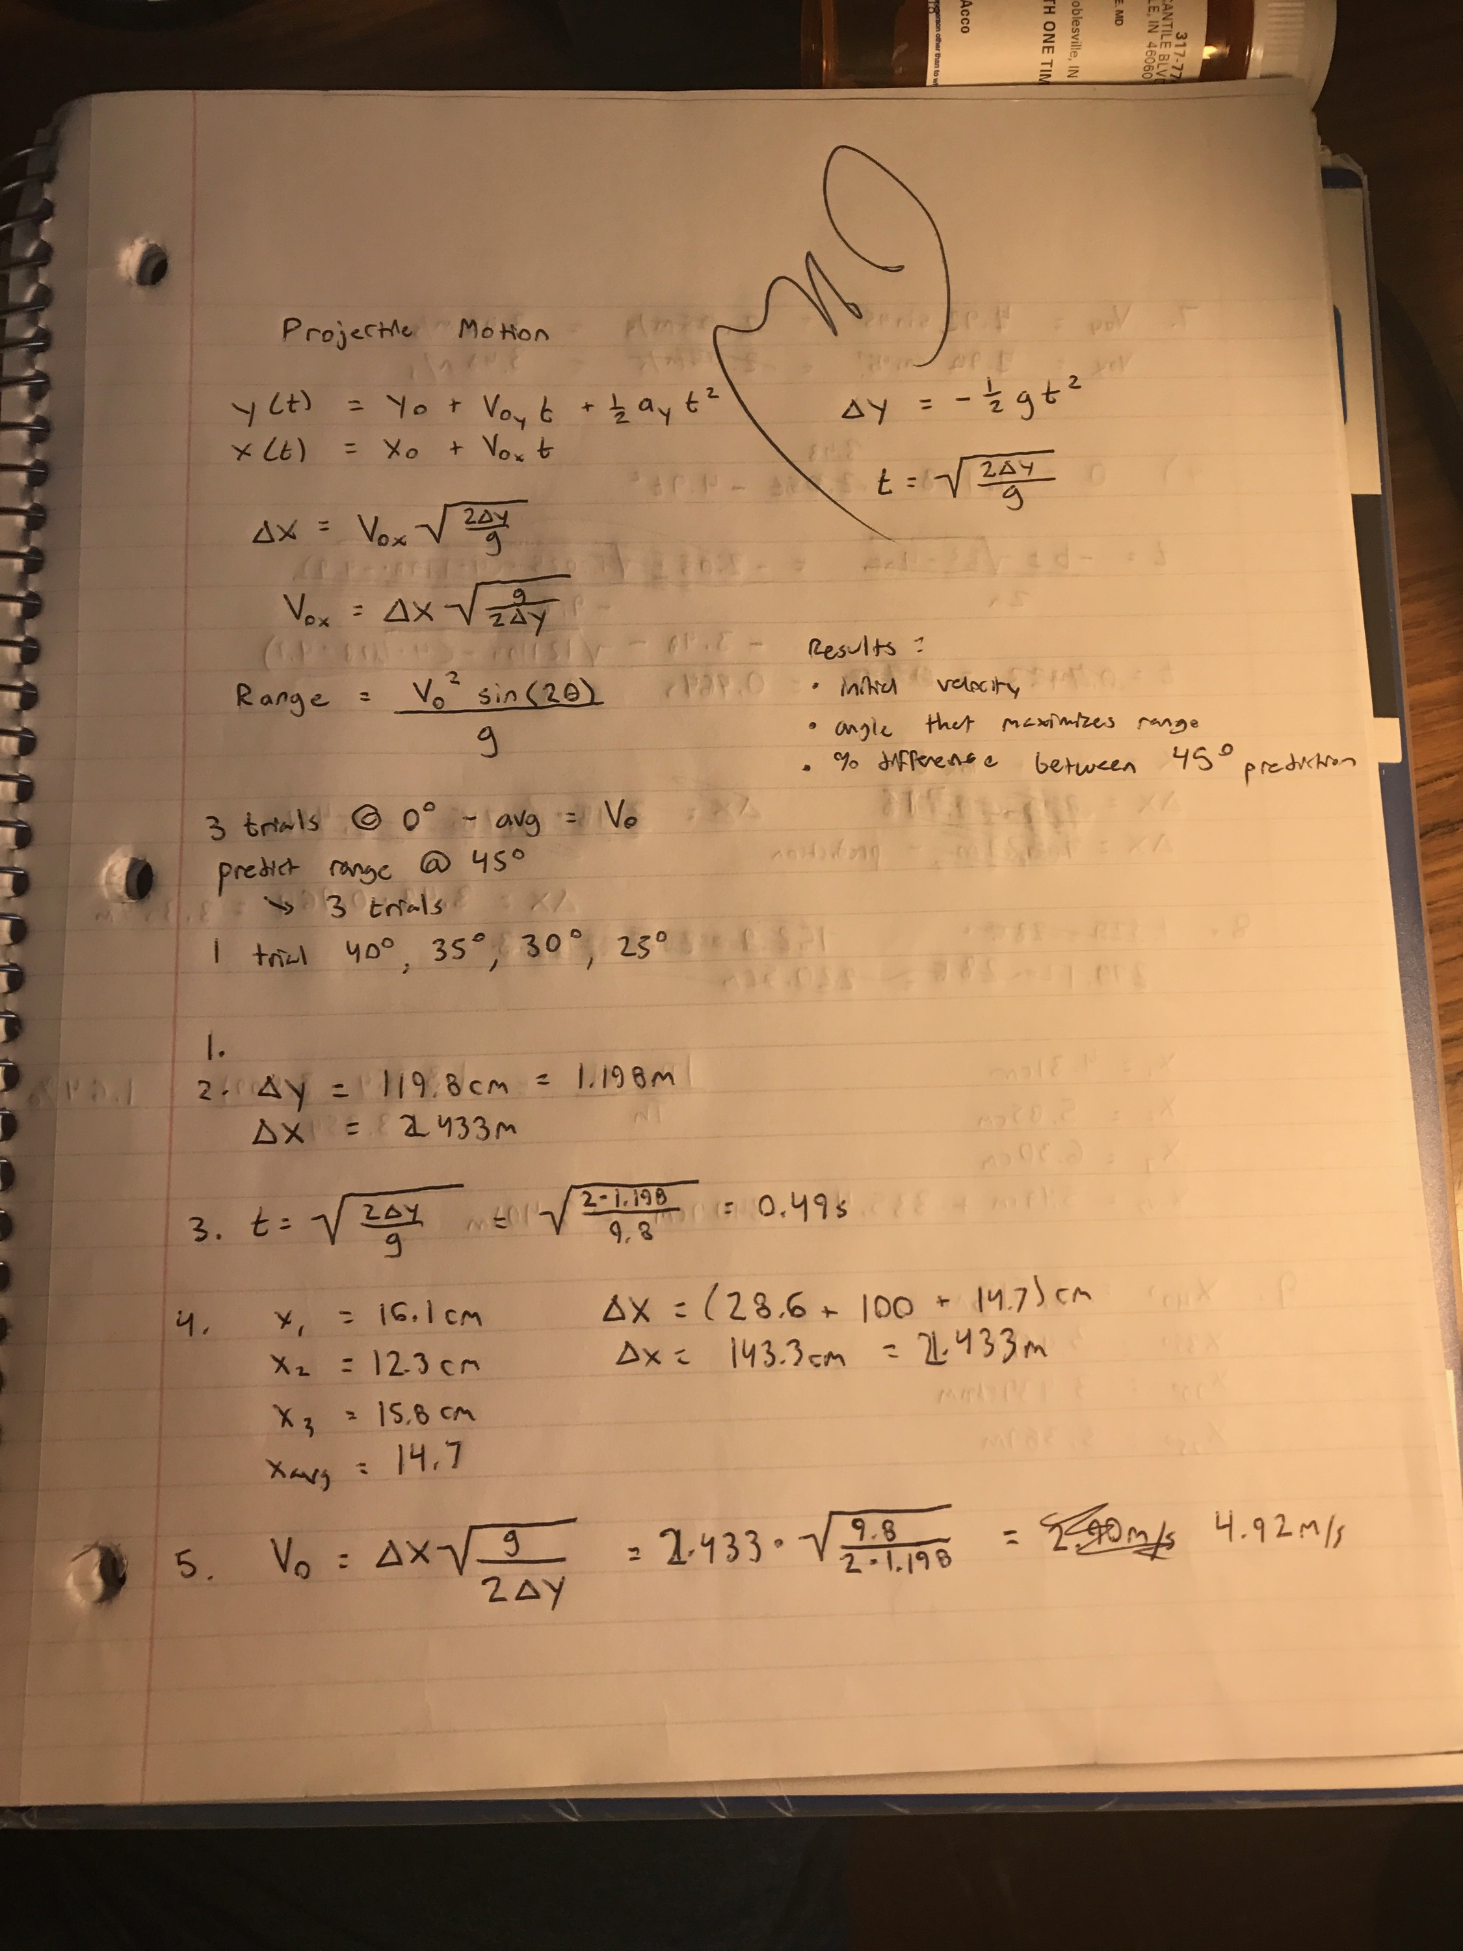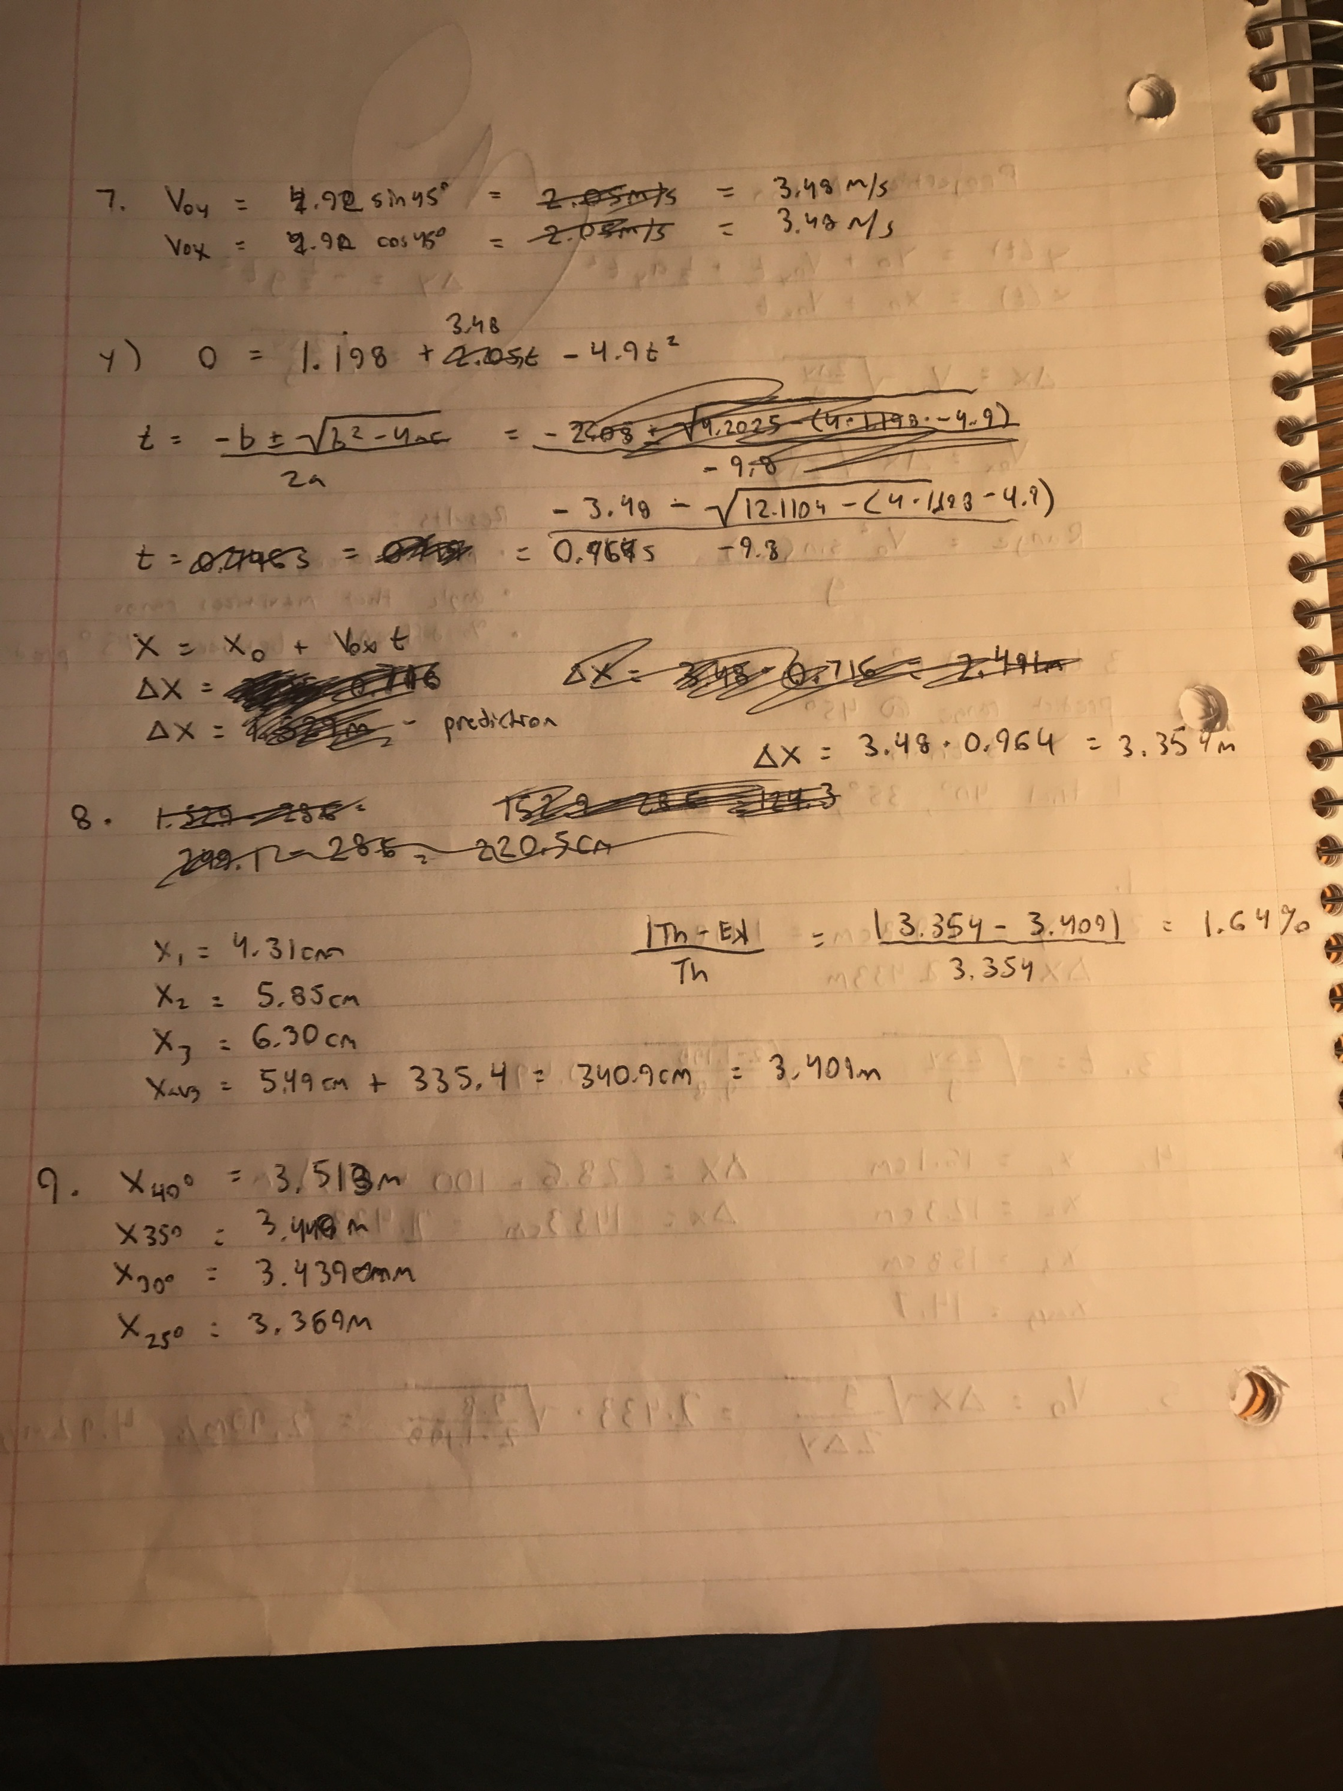

**Lab Manual Questions**

